Stanford.com

|  |  |  |  |
| --- | --- | --- | --- |
| *S.no* |  | *Student ID* | *Student Name* |
| 1 |  | Student1421655 | Muhammad Fahim |
| 2 |  | Student | Cristopher |

**Project Advisor**

Sir Owais Ahmed



Website Name: **Stanford.com**

**Main Pages in Website:**

1. Home
2. Other Courses
3. Our Faculty
4. Main Courses

**Technology am i using:**

1. HTML 5
2. CSS 3
3. Bootstrap 5 (Framework of CSS)
4. JavaScript
5. JQuery
6. Font Awesome

**ACKNOWLEDGEMENT**

First of all we would like to thank ALLAH the almighty who make us able to complete this project.

After that we would like to express profound gratitude to our internal project advisor, Center Senior Faculty, ***Engr. Nazish Sattar***, for her precious support, back-up, supervision and useful suggestions throughout this project. Her moral support and continuous help enabled us to complete our work successfully. We are also highly thankful to the ***Center Management*** for their valuable suggestions, healthy analysis and support throughout this project.

We are grateful to the faculty members of Aptech Korangi Center who were always there to help us despite of their personal workload.

We are as ever, especially indebted to our parents for their love and support throughout our life. We also wish to thank our classmates, friends and all the individuals or groups that were involved in this project by any mean.

**Requirements of Projects:**

1. The Top of the Page should be presented with a suitable logo and various

Famous images of respective beaches.

1. The site must contain the links to navigate through any zone for the

information.

3. Links of beaches can be categorized by zone wise like (East, North, West and

South)

4. Gallery can be added for viewing different images.

5. Feedback must be allowed to enter by the viewer

6. Site map, Gallery, about us, Queries link, Contact us link must be added.

7. About Us and Contact Us: This menu option should display Email id, address,

and contact number of the organization who is developing the system.

8. The complete details and description must be allowed to get download as pdf

or doc file.

8. The advertise section of bus, flights can be included for reaching the places.

Over and above this, the portal should implement the following functionalities:

1. Display a continuous scrolling ticker at the bottom of the page with current date,

time, and location (hint: Use geolocation features of HTML5).

2. Display a visitor count at the top right corner of the page beside a logo image.

3. The menu options should change color on hover and also after clicking.

4. Fade in and fade out options can be used for the menus.

9. The site should have appropriate look and feel suitable to company’s

reputation and status.

**HEADER**

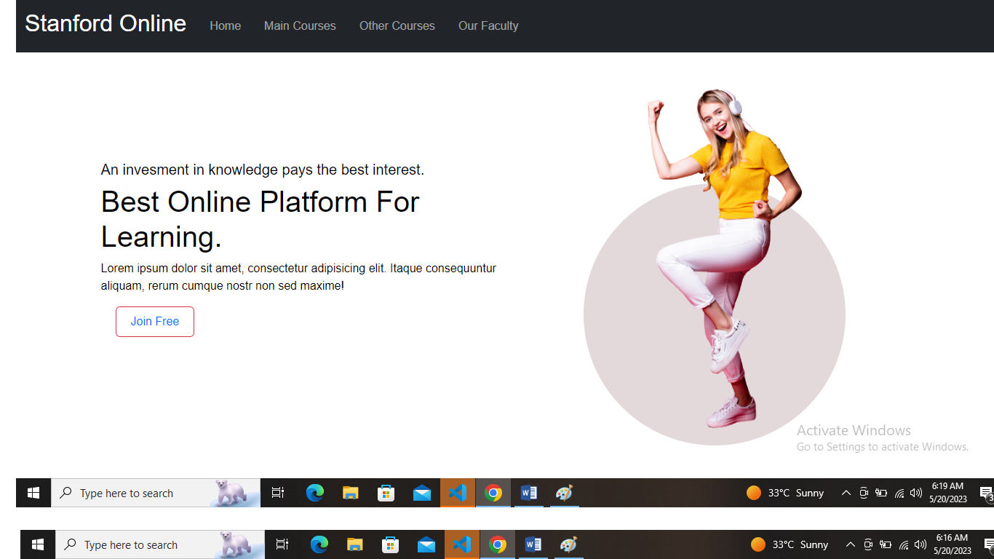

**FOOTER**

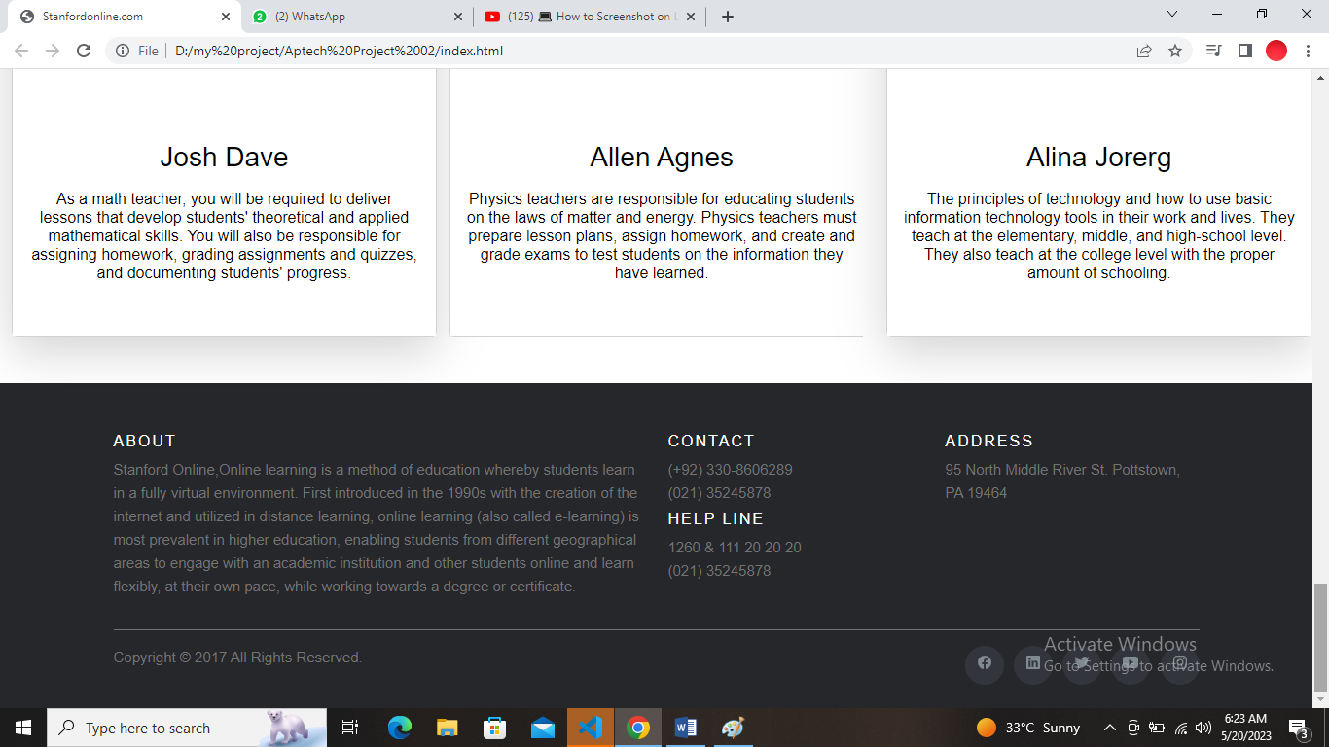

**HOME PAGE**

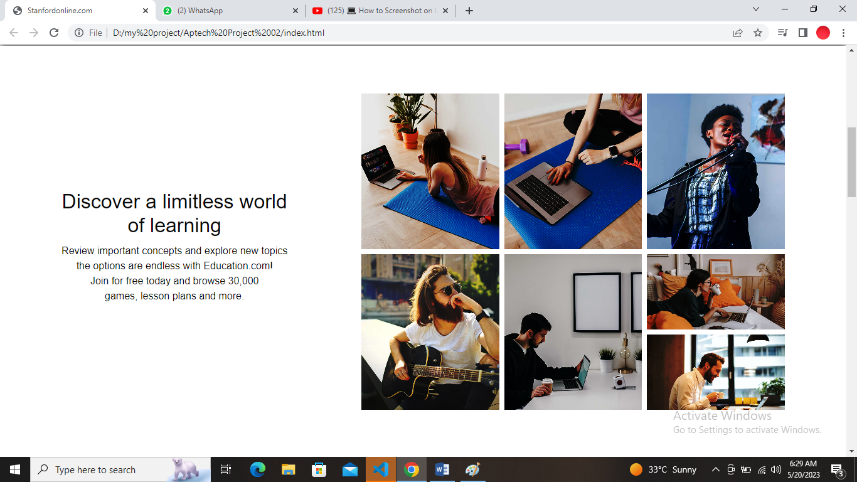

**CAROUSEL**

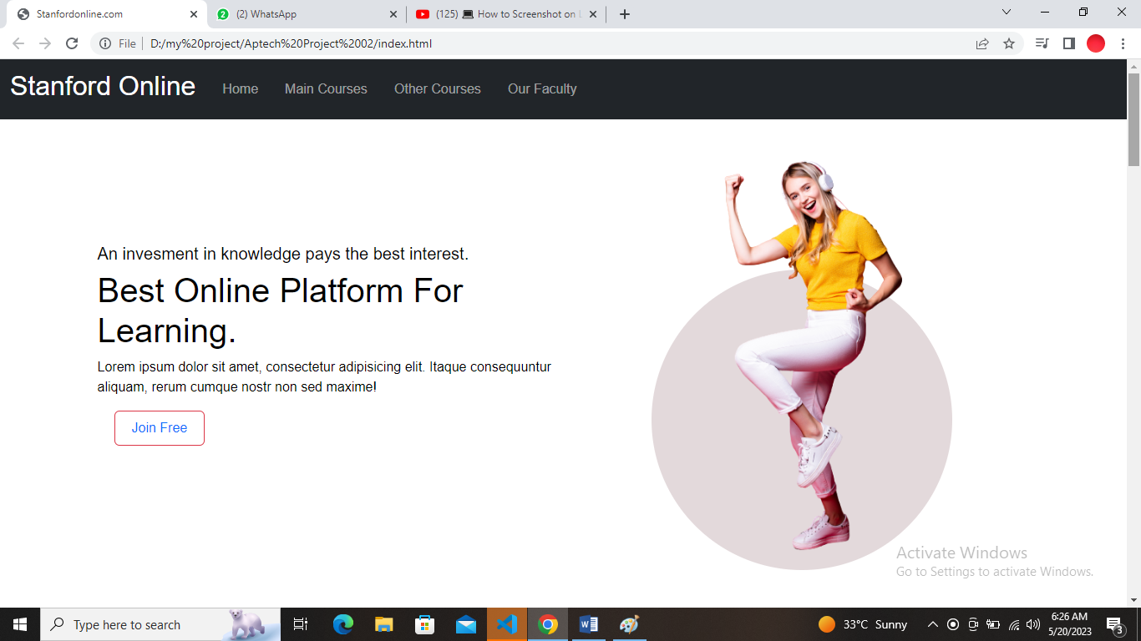

**TEACHER DETAIL**

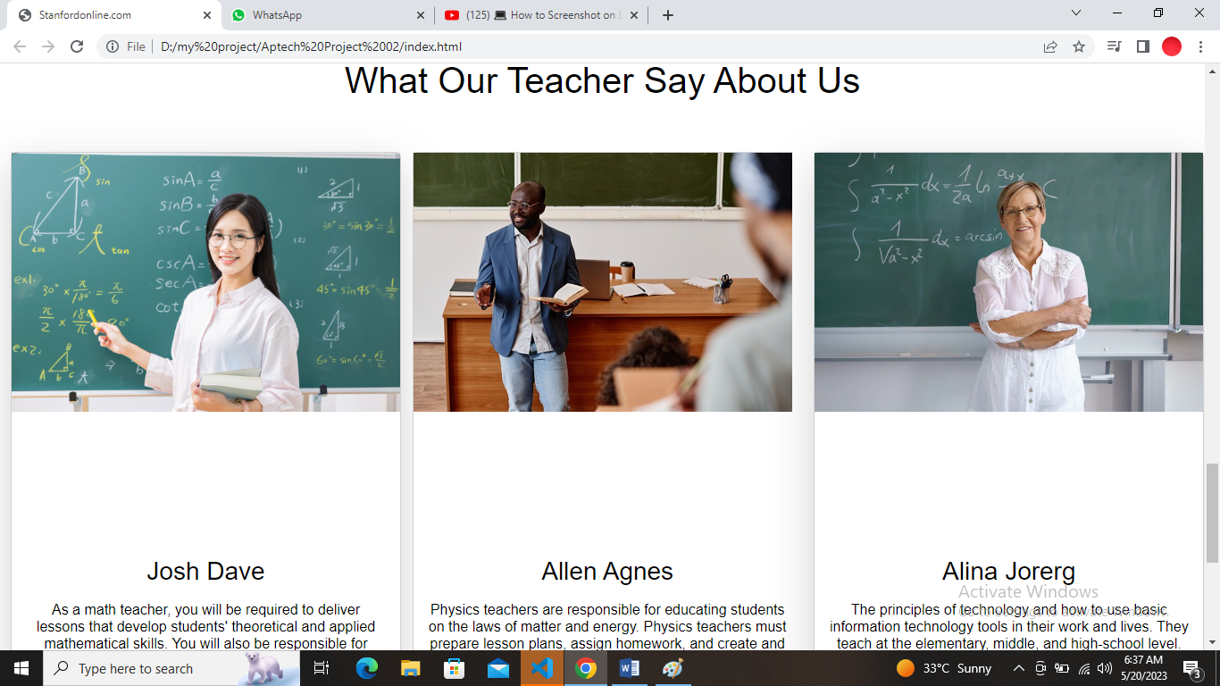

**MAIN COURSES DETAIL**

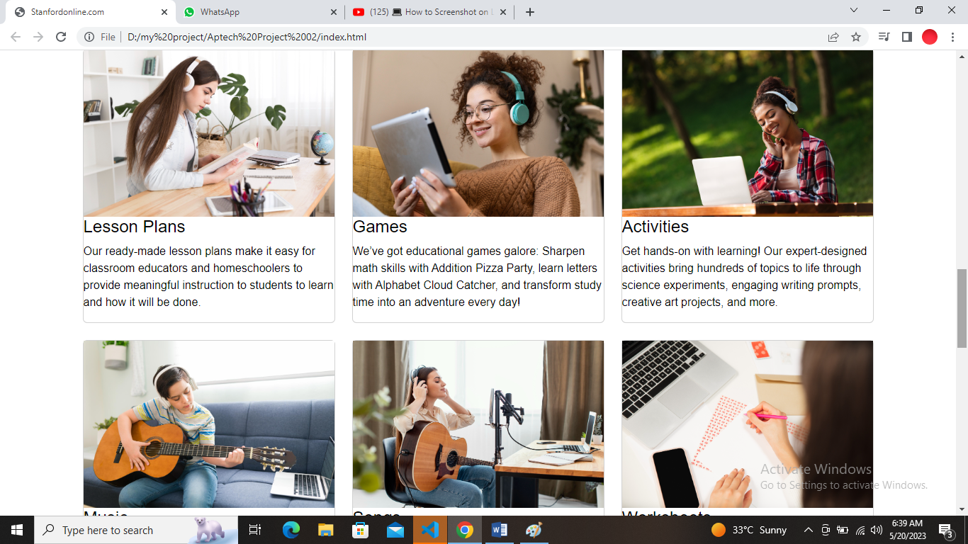

## LEARNING DETAILS

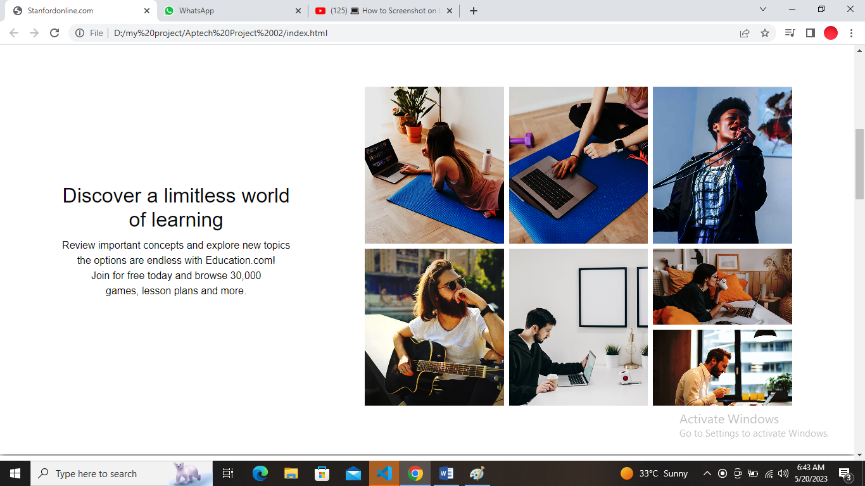

JOINING FORM

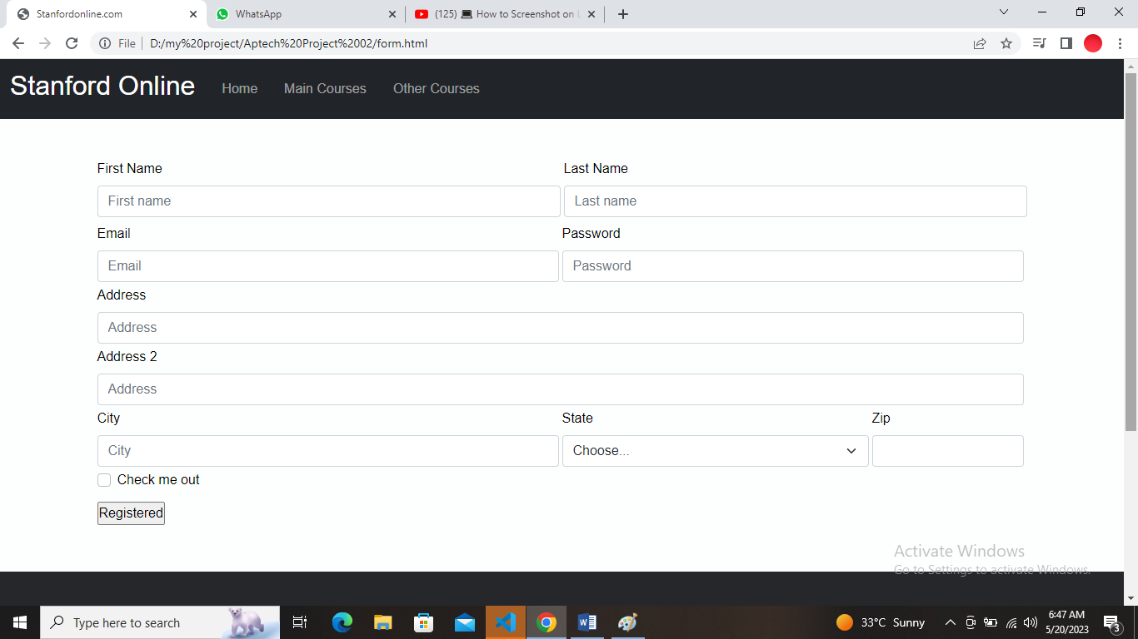

**OTHER COURSES PAGE**

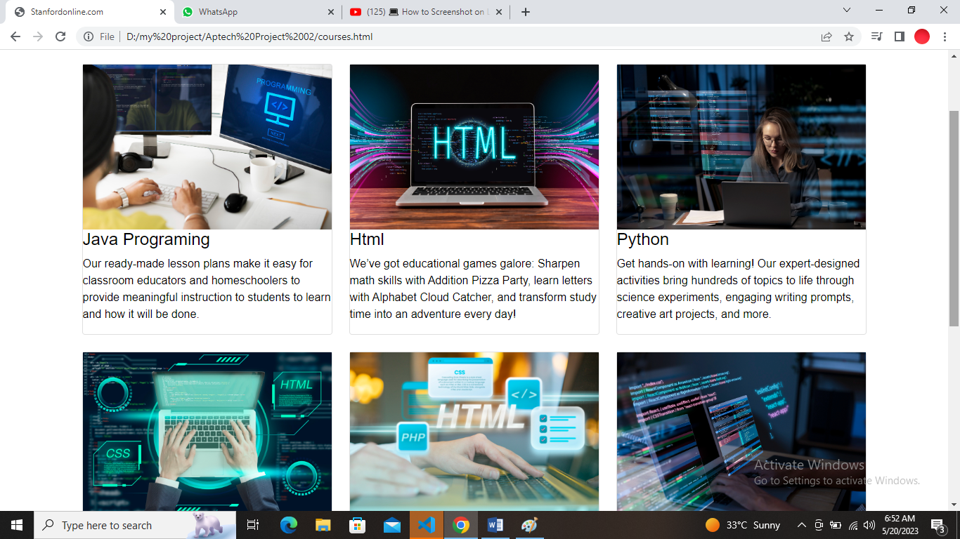

1. **Header & Navbar Coding**
2. <nav class="navbar navbar-expand-lg bg-dark navbar-dark">
3. <div class="container-fluid">
4. <a class="navbar-brand" href="#"><h2>Stanford Online</h2></a>
5. <button class="navbar-toggler" type="button" data-bs-toggle="collapse" data-bs-target="#navbarSupportedContent" aria-controls="navbarSupportedContent" aria-expanded="false" aria-label="Toggle navigation">
6. <span class="navbar-toggler-icon"></span>
7. </button>
8. <div class="collapse navbar-collapse" id="navbarSupportedContent">
9. <ul class="navbar-nav me-auto mb-2 mb-lg-0">
10. <li class="nav-link scrollto">
11. <a class="nav-link" href="#">Home</a>
12. </li>
13. <li class="nav-link scrollto">
14. <a class="nav-link" href="#services">Main Courses</a>
15. </li>
16. <li class="nav-link scrollto">
17. <a class="nav-link" href="courses.html">Other Courses</a>
18. </li>
19. <li class="nav-link scrollto">
20. <a class="nav-link" href="#services2">Our Faculty</a>
21. </li>
22. <li class="nav-item">
23. <a class="nav-link" href=""></a>
24. </li>
26. </ul>
28. </div>
29. </div>
30. </nav>
31. <section class="banner-section d-flex align-items-center">
32. <div class="container">
33. <div class="row align-items-center">
34. <div class="col-md-6">
35. <div class="banner-text">
36. <h5 class="md-3">An invesment in knowledge pays the best interest.</h5>
37. <h1 class="md-3 text-capitalize">best online platform for learning.</h1>
38. <p class="md-4">Lorem ipsum dolor sit amet, consectetur adipisicing elit. Itaque consequuntur aliquam, rerum
39. cumque nostr non sed maxime!</p>
40. <a href="form.html"><button type="button" class="btn btn-danger">Join Free</button></a>
41. </div>
42. </div>
43. <div class="col-md-6">
44. <div class="banner-img">
45. <div class="circular-img">
46. <div class="circular-img-inner">
47. <div class="circular-img-circle"></div>
48. <div class="zoom">
49. <img src="img/banner-img3.png" alt="banner img">
50. </div>
51. </div>
52. </div>
53. </div>
54. </div>
55. </div>
56. </div>
57. </section>
58. <br><br><br>
60. </section>

63. <div class="container-two">
64. <div class="text-center">
65. <h2 class="heading">Discover a limitless world <br>
66. of learning
67. </h2>
68. <p class="subheading">Review important concepts and explore new topics <br>
69. the options are endless with Education.com! <br>
70. Join for free today and browse 30,000 <br>
71. games, lesson plans and more.
72. </p>
73. </div>
74. <div class="gallery">
75. <div class="box-two row-2" id="box-1" style="background-image: url(img/courses/health/1.jpg);"></div>
76. <div class="box-two row-2" style="background-image: url(img/courses/health/2.jpg);"></div>
77. <div class="box-two row-2" style="background-image: url(img/courses/music/1.jpg);"></div>
78. <div class="box-two row-2" style="background-image: url(img/courses/music/2.jpg);"></div>
79. <div class="box-two row-2" style="background-image: url(img/courses/web-development/1.jpg);"></div>
80. <div class="box-two " style="background-image: url(img/courses/web-development/2.jpg);"></div>
81. <div class="box-two " style="background-image: url(img/courses/web-development/4.jpg);"></div>
82. </div>
84. </div>
85. <div class="card-body">
86. <h2 class="card-title">Our learning library</h2>
87. <p class="card-text">With 30,000+ digital and printable resources, kids can learn about any about.topic they're curious  </p>
88. <a href="form.html"><button type="button" class="btn btn-danger">Join Free</button></a>
90. </div>
92. </div>
94. <section id="services" class="services-wrapper-wrapper">
95. <div class="container">
96. <div class="row">
97. <div class="col-sm-12 text-center mb-5">
98. <h3>Main Cources</h3>
99. </div>
100. </div>
101. <div class="row">
102. <div class="col-md-4 col-sm-6 mb-4">
103. <div class="card">
104. <div class="icon-box">
105. <div class="zoom">
106. <img src="img/lesoon.jpg">
107. </div>
108. </div>
109. <div>
110. <h4>Lesson Plans</h4>
111. <p>Our ready-made lesson plans make it easy for
112. classroom educators and homeschoolers to provide
113. meaningful instruction to students
114. to learn and how it will be done.</p>
115. </div>
116. </div>
117. </div>
118. <div class="col-md-4 col-sm-6 mb-4">
119. <div class="card">
120. <div class="icon-box">
121. <div class="zoom">
122. <img src="img/games.jpg">
123. </div>
124. </div>
125. <div>
126. <h4>Games</h4>
127. <p>We’ve got educational games galore: Sharpen math
128. skills with Addition Pizza Party, learn letters with
129. Alphabet Cloud Catcher, and transform study time
130. into an adventure every day!
131. </p>
132. </div>
133. </div>
134. </div>
135. <div class="col-md-4 col-sm-6 mb-4">
136. <div class="card">
137. <div class="icon-box">
138. <div class="zoom">
139. <img src="img/activitis.jpg">
140. </div>
141. </div>
142. <div>
143. <h4>Activities</h4>
144. <p>Get hands-on with learning! Our expert-designed activities bring hundreds of topics to life through science experiments, engaging writing prompts, creative art projects, and more.
145. </p>
146. </div>
147. </div>
148. </div>
149. <div class="col-md-4 col-sm-6 mb-4">
150. <div class="card">
151. <div class="icon-box">
152. <div class="zoom">
153. <img src="img/music.jpg">
154. </div>
155. </div>
156. <div>
157. <h4>Music</h4>
158. <p>We're Making Music for Life. Checkout are different programs to know more. We teach wide range of music instruments. Pick your favourite instrument and learn.</p>
159. </div>
160. </div>
161. </div>
162. <div class="col-md-4 col-sm-6 mb-4">
163. <div class="card">
164. <div class="icon-box">
165. <div class="zoom">
166. <img src="img/song.jpg">
167. </div>
168. </div>
169. <div>
170. <h4>Songs</h4>
171. <p>A song is a short poem or story set to music with a melody and vocals. Lyrics, verses, refrain, and meter are the main components of a song. The lyrics of a song are the words set to the music.</p>
172. </div>
173. </div>
174. </div>
175. <div class="col-md-4 col-sm-6 mb-4">
176. <div class="card">
177. <div class="icon-box">
178. <div class="zoom">
179. <img src="img/worksheet.jpg">
180. </div>
181. </div>
182. <div>
183. <h4>Worksheets</h4>
184. <p>What does your student want to lean? We've got a
185. Worksheet for that! Our printables are a fun and easy
186. way to learn about multiplication, sight word, animal
187. life cycle, and much more!
189. </p>
190. </div>
191. </div>
192. </div>
193. </div>
195. </div>
197. </section>
198. <section id="services2" class="container-fluid">
199. <div class="container-fluid text-center">
200. <h1>What Our Teacher Say About Us </h1>
201. </div>
202. <div class="team row py-5">
203. <div class="col-md-4 col-12 text-center">
204. <div class="card mr-2 d-inline-block shadow-lg">
205. <div class="card-img-top">
206. <div class="photo">
207. <img src="Img/teacher1.img.jpeg" alt="Mamber" class="img-fluid">
208. </div>
209. </div>
210. <div class="card-body py-8">
211. <h3 class="card-title">Josh Dave</h3>
212. <p class="card-text">
213. <h6> As a math teacher, you will be required to deliver lessons
214. that develop students' theoretical and applied mathematical skills.
215. You will also be responsible for assigning homework,
216. grading assignments and quizzes, and documenting students' progress.</h6>
217. </p>
218. </div>
219. </div>
220. </div>
221. <div class="col-md-4 col-12">
222. <!--Carousel Started-->
223. <div id="carouselExampleSlidesOnly" class="carousel slide" data-ride="carousel">
224. <div class="carousel-inner">
225. <div class="carousel-item active text-center">
226. <!--card 2-->
227. <div class="card mr-2 d-inline-block shadow-lg">
228. <div class="card-img-top">
229. <div class="photo">
230. <img src="img/teacher2.img.jpeg" alt="Mamber" class="img-fluid">
231. </div>
232. </div>
233. <div class="card-body">
234. <h3 class="card-title py-8">Allen Agnes</h3>
235. <p class="card-text">
236. <h6> Physics teachers are responsible for educating students on the laws of matter and energy. Physics teachers must prepare lesson plans, assign homework, and create and grade exams to test students on the information they have learned.</h6>
237. </p>
238. </div>
239. </div>
240. </div>
242. </div>
243. </div>
244. </div>
245. <div class="col-md-4 col-12 text-center">
246. <!--card 4-->
247. <div class="card mr-2 d-inline-block shadow-lg">
248. <div class="card-img-top">
249. <div class="photo">
250. <img src="Img/teacher3.img.jpeg" alt="Mamber" class="img-fluid">
251. </div>
252. </div>
253. <div class="card-body py-8">
254. <h3 class="card-title">Alina Jorerg</h3>
255. <p class="card-text">
256. <h6>The principles of technology and how to use basic information technology
257. tools in their work and lives. They teach at the elementary, middle, and high-school level.
258. They also teach at the college level with the proper amount of schooling.</h6>
259. </p>
260. </div>
261. </div>
262. </div>
263. </div>
264. </section>
266. </main>
268. <!-- Site footer -->
269. <footer class="site-footer">
270. <div class="container">
271. <div class="row">
272. <div class="col-sm-12 col-md-6">
273. <h6>About</h6>
274. <p class="text-justify">Stanford Online,Online learning is a method of education whereby students learn in a fully virtual environment. First introduced in the 1990s with the creation of the internet and utilized in distance learning, online learning (also called e-learning) is most prevalent in higher education, enabling students from different geographical areas to engage with an academic institution and other students online and learn flexibly, at their own pace, while working towards a degree or certificate.
275. </p>
276. </div>
277. <div class="col-xs-6 col-md-3">
278. <h6>Contact</h6>
279. <ul class="footer-links">
280. <li>(+92) 330-8606289</li>
281. <li>(021) 35245878</li>
282. <h6>Help Line</h6>
283. <ul class="footer-links">
284. <li>1260 & 111 20 20 20</li>
285. <li>(021) 35245878</li>
287. </ul>
288. </div>
289. <div class="col-xs-6 col-md-3">
290. <h6>Address</h6>
291. <ul class="footer-links">
292. <li>95 North Middle River St.
293. Pottstown, PA 19464</li>
295. </ul>
296. </div>
297. </div>
298. <hr>
299. </div>
300. <div class="container">
301. <div class="row">
302. <div class="col-md-8 col-sm-6 col-xs-12">
303. <p class="copyright-text">Copyright &copy; 2017 All Rights Reserved.
305. </p>
306. </div>
307. <div class="col-md-4 col-sm-6 col-xs-12">
308. <ul class="social-icons">
309. <li><a href=""><ion-icon name="logo-facebook"></ion-icon></a></li>
310. <li><a href=""><ion-icon name="logo-linkedin"></ion-icon></a></li>
311. <li><a href=""><ion-icon name="logo-Twitter"></ion-icon></a></li>
312. <li><a href=""><ion-icon name="logo-Youtube"></ion-icon></a></li>
313. <li><a href=""><ion-icon name="logo-instagram"></ion-icon></a></li>
315. </ul>
316. </div>
317. </div>
318. </div>
319. </footer>

**FIRST SEMESTER**

**PROJECT**

**STANFORDONLINE**